Class:6 Date: 09-06-2024
Agenda:
- Recap of Hadoop Architecture.
- Linux Commands Handson
- Hadoop Commands Handson
Revise clustering concepts from class 3.
We need Linux commands to talk to Gateway Node and Hadoop commands to talk to HDFS.
Known FACTS:
In 1900s, we are not used to have any windows OS, MacOS, etc we used to talk to machine in COMMANDS.
Windows OS, from frontend we do in UI(creating folders, files, update, delete etc), but at backend for everything gets converted into commands and gets executed.
The Entire BIG DATA Environment runs on LINUX OS. In LINUX, we don’t have UI in Real-time because of security reasons, only way to communicate is with COMMANDS.
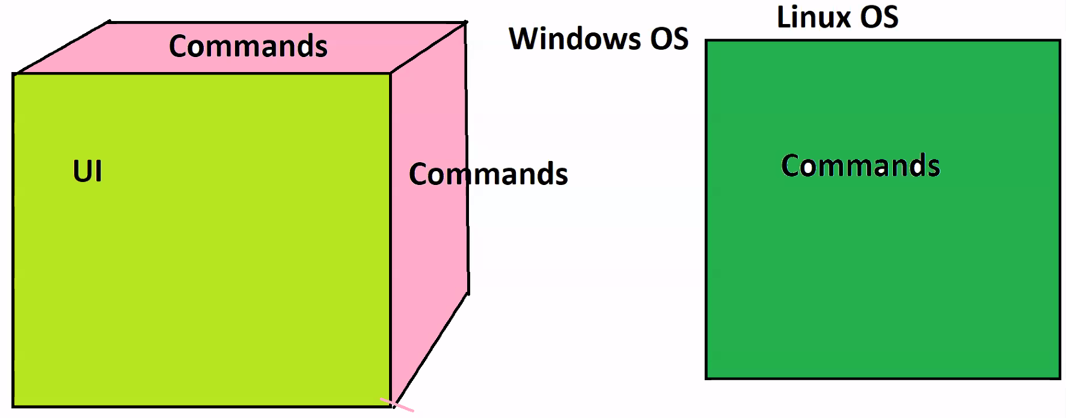
Why Commands:
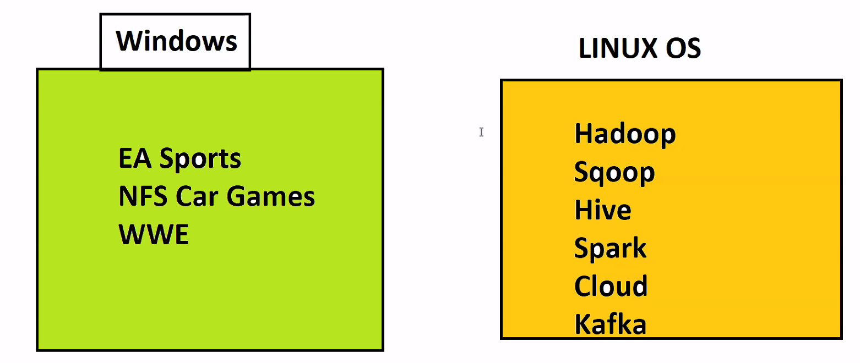

BASIC LINUX COMMANDS:
ifconfig To get IP Address, User details.
pwd To get current working path/directory /home/cloudera
ls To list all Folders and Files of a directory.
ll long listing, To get detailed information of each folder and files, like size, who created it, who modified it etc.
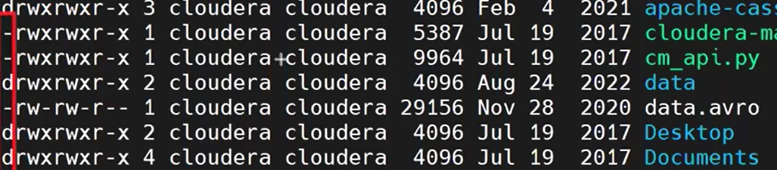
In the above image, First character represents whether it is file or folder.
Hyphen - Represents file, d represents Folder.
Clear Clears the screen.
mkdir<space><new directory name> Create a new directory
cd <path of dir or dir name> Change / go inside the directory.
cd<space>.. Brings back to one step before directory
touch<space><file name> would create an empty file.
cp to copy files from one place to another
mv to move files from one place to another
rm to remove/delete file.
rmdir to delete a directory
Landing path of Edge Node ‘/home/cloudera’
Going between directories one step forward and one step backward, that’s RELATIVE PATH.
Going from one path to another path using full path, that’s ABSOLUTE PATH.
cd /home/cloudera/z1/z11 Absolute path
To create/delete/edit something you need not to traverse backward and forward, use fullpath.

touch /home/cloudera/z2/z22/zfile , ll /home/cloudera/z2/z22
echo <sometext> It prints text in terminal
echo <sometext> > <filename> writes text to given filename.
Cat <filename> to read the content of the file.
When we don’t have any extension to file, that file is called Flat Files. It can have any type of data.

Hadoop Commands:
Always use Full path, i.e, Absolute path with Hadoop commands.
Hadoop commands are same as Linux commands, just prefix it with ‘hadoop fs -’
Landing path of edge node is /user/cloudera .
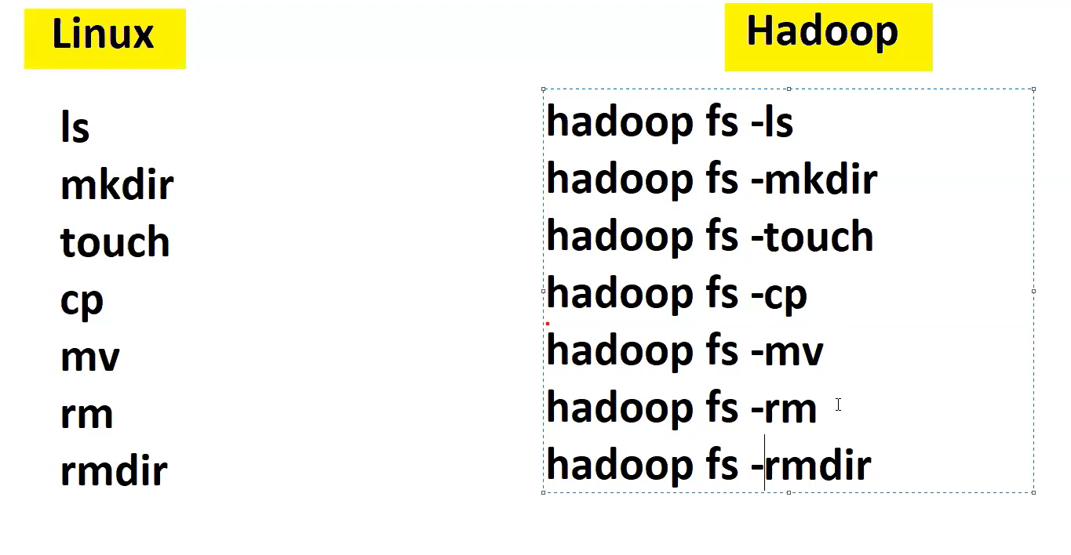 Class:7 Date: 15-06-2024
Agenda: Hadoops commands deep dive
We need to worry about Name Node, Journal Nodes, secondary Name Node, admin team will be taken care.
Treat HDFS as single filesystem.(treat it as single big node). We can create, update, delete files in HDFS.
Landing path of HDFS: /user/cloudera/
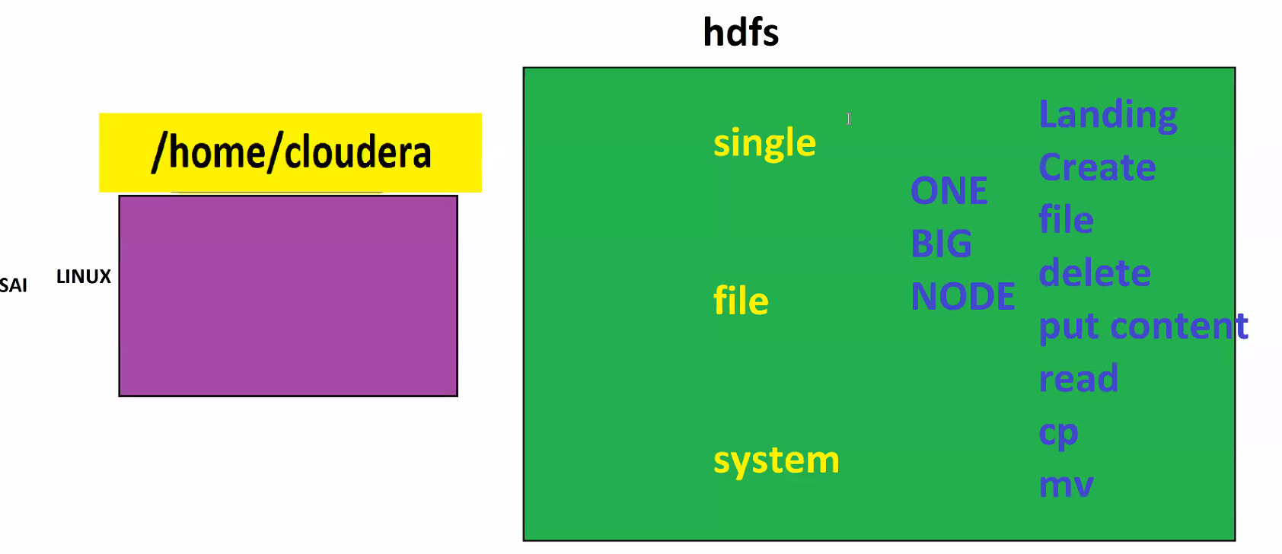

Every Hadoop commands is Java commands, it takes time to execute.
hadoop fs -ls /user/cloudera listing the content of HDFS home
hadoop fs -mkdir /user/cloudera/zeyodir to create a folder inside HDFS
hadoop fs -ls /user/cloudera/ to list all files and directory in hdfs
Hadoop does not have ll command. Use only ls.
Hadoop fs -rmdir /user/cloudera/zhdir to remove dir in hdfs
Hadoop dfsadmin -safemode leave when cloudera gets restarted name node goes sleep mode, before executing any hdfs command execute this command.
touch wont work in hadoop, instead use touchz
hadoop fs -touchz /user/cloudera/firstdir/zeyohfile to creat empty file in HDFS.
Directories inside HDFS are not physical directories, they are virtual directories.
BOSS STORY – COMMANDS:
Boss – create a directory called ‘edgedir’ in edge node. Create another directory ‘hdfsdir’ in hdfs.
mkdir /home/cloudera/edgedir
hadoop fs -mkdir /user/cloudera/hdfsdir
Boss – create a ‘edgefile’ file in edgenode inside ‘edgedir’, with content ‘zeyo‘ init.
echo zeyo > /home/cloudera/edgedir/edgefile
Boss – find a way to put a copy of edgefile to hdfs dir
To copy data from edge node to hdfs, we use put command.
hadoop fs -put <SOURCE EDGE NODE path> <TARGET HDFS path>
hadoop fs -put /home/cloudera/edgedir/edgefile /user/cloudera/hdfsdir
Boss – read this edgefile from hdfs dir.
hadoop fs -cat /user/cloudera/hdfsdir/edgefile
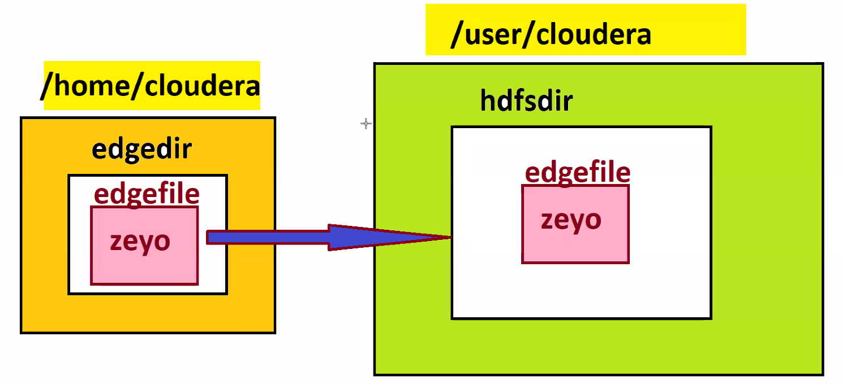
Class:8 Date: 16-06-2024
Agenda:
- Recap of Hadoop
- Get command
- Serialized data reads
- Cloud bit
BOSS STORY CONT..
BOSS – just to practise, can you create a ‘edgeout‘ dir in edgenode. Get copy of file from HDFS to edgenode edgeout.
get command is used to get file from HDFS to edge node and put command to put data from edgenode to HDFS
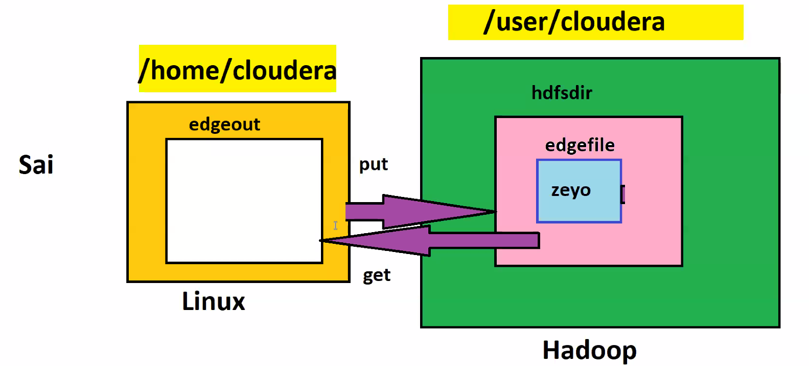
Get command hadoop -get <HDFS_SOURCE_PATH> <EDGENODE_TARGET_PATH>
mkdir /home/cloudera/edgeout
hadoop fs -get /user/clouders/hdfsdir/edgefile /home/cloudera/edgeout
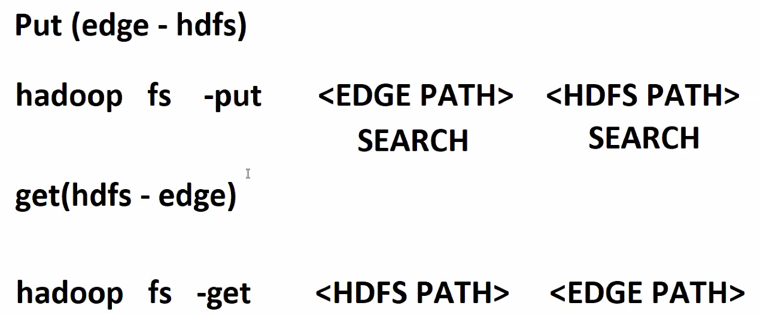
Whenever data is moving between HDFS and EDGE NODE we use get command. We are moving data from edgenode to edgenode or HDFS to HDFS, we use cp command.

Hadoop commands on Cloud environment:
Now we have integrated AWS, we could also able to talk to edge node. HDFS and AWS cloud also.
Landing page of AWS cloud storage is s3a://<BUCKET_NAME> /
hadoop fs -ls s3a://<BUCKET_NAME>/ to list cloud directory
Copying files from edge node to cloud using put command
hadoop fs -put /home/cloudera/edgedir/edgefile s3a://<bucket_name>/
Creating dir inside cloud bucket
hadoop fs -mkdir s3a://<bucket_name>/<dirname>
NOTE: SAME HAOOOP COMMANS WILL ALSO WORK FOR CLOUD STORAGE.
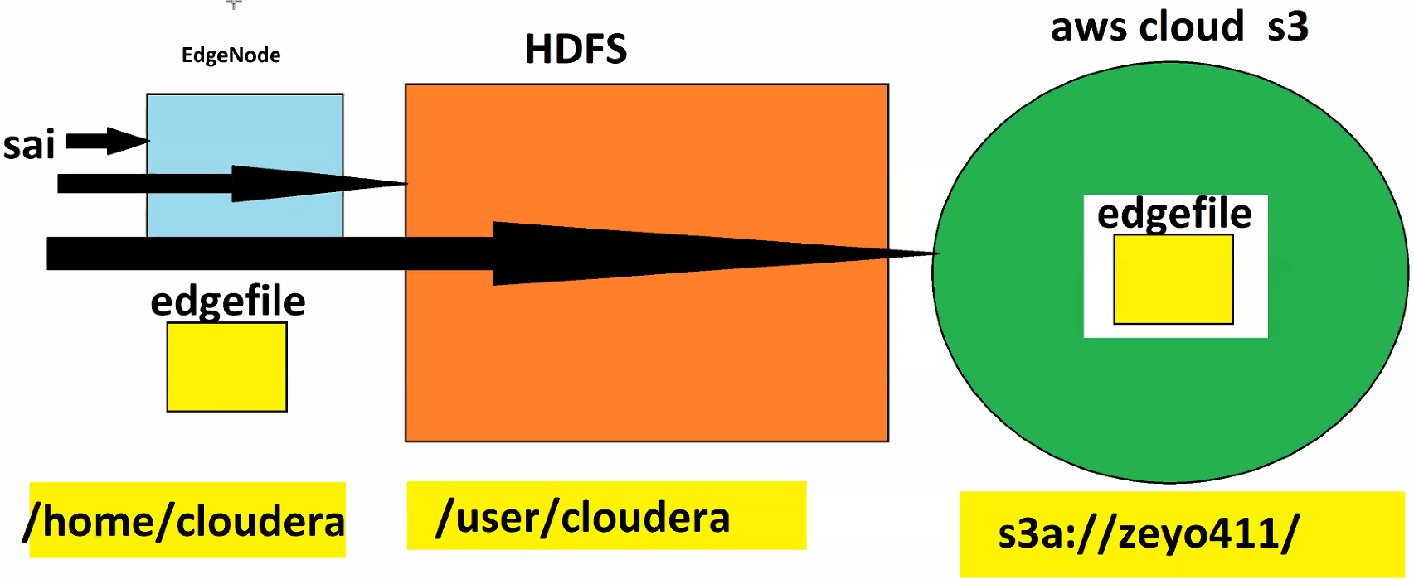

Serialized Data Reads:
We have file called data.avro. We cannot read avro file directly using CAT command. Its not in readable format. In data world, we call this data as serialized data.
In real-time, in Big-data env, entire data is serialized data, we deal with lots of lots of serialized data.
There are many serialized data formats like Sequence, parquet, avro etc.
To deserialize the serialize data, we have HIVE, SPARK.
